Ex11

import cv2
import matplotlib.pyplot as plt
from google.colab import files
import numpy as np
uploaded = files.upload()
filename = next(iter(uploaded))
img = cv2.imdecode(np.frombuffer(uploaded[filename], np.uint8), cv2.IMREAD_COLOR)
if img is None:
raise ValueError("Unable to read image.")
rotated = cv2.rotate(img, cv2.ROTATE_180)
plt.figure(figsize=(10, 4))
plt.subplot(1, 2, 1)
plt.imshow(cv2.cvtColor(img, cv2.COLOR_BGR2RGB))
plt.title("Original")
plt.axis("off")
plt.subplot(1, 2, 2)
plt.imshow(cv2.cvtColor(rotated, cv2.COLOR_BGR2RGB))
plt.title("180 Degrees Clockwise")
plt.axis("off")
plt.show()
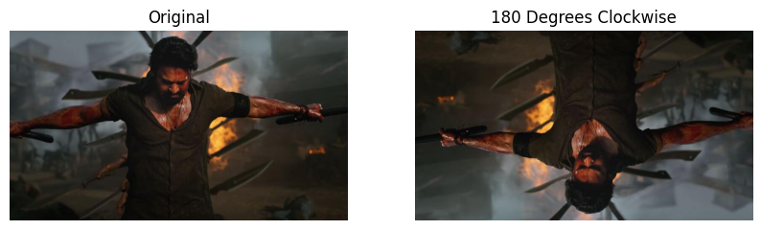

Ex12

import cv2
import matplotlib.pyplot as plt
from google.colab import files
import numpy as np
uploaded = files.upload()
filename = next(iter(uploaded))
img = cv2.imdecode(np.frombuffer(uploaded[filename], np.uint8), cv2.IMREAD_COLOR)
if img is None:
raise ValueError("Unable to read image.")
rotated = cv2.rotate(img, cv2.ROTATE_90_COUNTERCLOCKWISE)
plt.figure(figsize=(10, 4))
plt.subplot(1, 2, 1)
plt.imshow(cv2.cvtColor(img, cv2.COLOR_BGR2RGB))
plt.title("Original")
plt.axis("off")
plt.subplot(1, 2, 2)
plt.imshow(cv2.cvtColor(rotated, cv2.COLOR_BGR2RGB))
plt.title("270 Degrees Clockwise")
plt.axis("off")
plt.show()

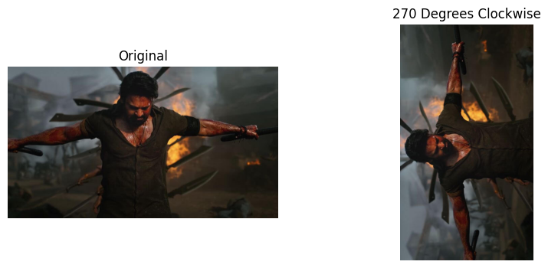

Ex13

import cv2
import matplotlib.pyplot as plt
from google.colab import files
import numpy as np
uploaded = files.upload()
filename = next(iter(uploaded))
img = cv2.imdecode(np.frombuffer(uploaded[filename], np.uint8), cv2.IMREAD_COLOR)
if img is None:
raise ValueError("Unable to read image.")
h, w = img.shape[:2]
source_points = np.float32([
[0, 0],
[w - 1, 0],
[0, h - 1]
])
destination_points = np.float32([
[w * 0.1, h * 0.1],
[w * 0.9, h * 0.2],
[w * 0.2, h * 0.9]
])
matrix = cv2.getAffineTransform(source_points, destination_points)
transformed = cv2.warpAffine(img, matrix, (w, h))
plt.figure(figsize=(10, 4))
plt.subplot(1, 2, 1)
plt.imshow(cv2.cvtColor(img, cv2.COLOR_BGR2RGB))
plt.title("Original")
plt.axis("off")
plt.subplot(1, 2, 2)
plt.imshow(cv2.cvtColor(transformed, cv2.COLOR_BGR2RGB))
plt.title("Affine Transformation")
plt.axis("off")
plt.show()


Ex14

import cv2
import matplotlib.pyplot as plt
from google.colab import files
import numpy as np
uploaded = files.upload()
filename = next(iter(uploaded))
img = cv2.imdecode(np.frombuffer(uploaded[filename], np.uint8), cv2.IMREAD_COLOR)
if img is None:
raise ValueError("Unable to read image.")
h, w = img.shape[:2]
source = np.float32([
[0, 0], [w - 1, 0],
[0, h - 1], [w - 1, h - 1]
])

destination = np.float32([
[w * 0.1, h * 0.1],
[w * 0.9, h * 0.0],
[w * 0.0, h * 0.9],
[w * 0.8, h * 0.8]
])
matrix = cv2.getPerspectiveTransform(source, destination)
transformed = cv2.warpPerspective(img, matrix, (w, h))
plt.figure(figsize=(10, 4))
plt.subplot(1, 2, 1)
plt.imshow(cv2.cvtColor(img, cv2.COLOR_BGR2RGB))
plt.title("Original")
plt.axis("off")
plt.subplot(1, 2, 2)
plt.imshow(cv2.cvtColor(transformed, cv2.COLOR_BGR2RGB))
plt.title("Perspective Transformation")
plt.axis("off")
plt.show()


Ex15

import cv2
import matplotlib.pyplot as plt
from google.colab import files
import numpy as np
uploaded = files.upload()
filename = next(iter(uploaded))
img = cv2.imdecode(np.frombuffer(uploaded[filename], np.uint8), cv2.IMREAD_COLOR)
if img is None:
raise ValueError("Unable to read image.")
gray = cv2.cvtColor(img, cv2.COLOR_BGR2GRAY)
gray_float = np.float32(gray)
corners = cv2.cornerHarris(gray_float, blockSize=2, ksize=3, k=0.04)
corners = cv2.dilate(corners, None)
result = img.copy()
result[corners > 0.01 * corners.max()] = [0, 0, 255]
plt.figure(figsize=(10, 4))
plt.subplot(1, 2, 1)
plt.imshow(cv2.cvtColor(img, cv2.COLOR_BGR2RGB))
plt.title("Original Image")
plt.axis("off")
plt.subplot(1, 2, 2)
plt.imshow(cv2.cvtColor(result, cv2.COLOR_BGR2RGB))
plt.title("Harris Corners in Red")
plt.axis("off")
plt.show()



